Muhammad Salihin Bin Zaol-kefli

**Description Of Scripts**

AStarPathfinding.cs

Finds and plots the path needed for the AI to chase the Player.

BitCollection.cs

Handles the collision between Player and the Bits and Big Bits. Add a certain point value depending on the Bit collided.

PlayerHUD.cs

Handles the HUD components of the Player and updates itself according to the situation, ie, minus Lives when an AI collides with the Player and gain points when Player collects Bits.

PlayerScript.cs

Handles the Player’s invulnerability mode which allows Player to eat an AI, add points depending on Bit collided, flickering of colour when in invulnerability mode and toggling between invulnerability mode and back within a set duration.

ShadowScript.cs

Handles the movement of the AI using A* Pathfinding. AI will chase the Player based on the plotted path. Does so only if the Player is within a set range.

TileScript.cs

Contains data for each tile in the level and assists in processing A* Pathfinding.

**A* AI**

A* Pathfinding is integrated into the AI to allow the AI to have a path plotted towards the Player in order for it to chase the Player.

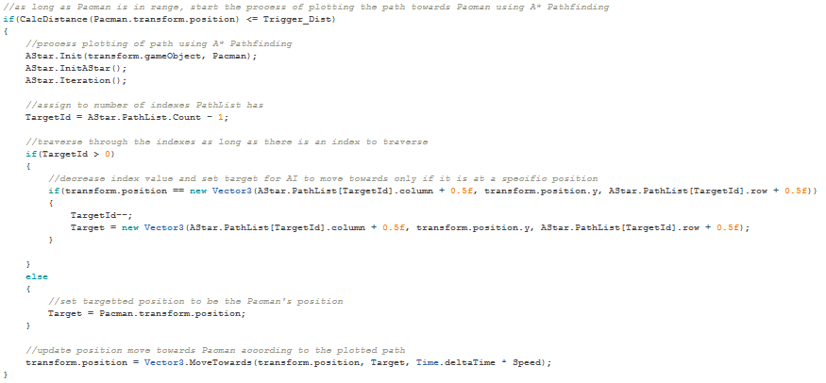

CalcDistance() calculates the distance between the AI and the Player.

AStar.Init() takes in the data of the AI and the Player and manipulates them for use in A* Pathfinding.

AStar.InitAStar() adds the current tile the AI is in to the OpenList.

AStar.Iteration()performs the iteration to add tiles into OpenList and CloseList and to plot path from AI to Pacman.